DZS-0.008-0.4
ELECTRIC
STEAM BOILER

INSTRUCTION
MANUAL

Reading the manual carefully before operating

Shanghai Weishi Machinery Co., Ltd
Add： 52 # No. 1089 Qinzhou, Road (N0 Shanghai China Post Code：200233
Telephone：86-21-64953003，64958277，64955983 Fax：64952757
I、Functions:
DQL series electric steam boilers are mini boilers that can automatic and consistently generate saturation steam. They can provide the dry steam that is necessary for the steam irons and steam pressing machines of the garment industry as well as offering the steam source for hospitals, restaurants, and sauna industries.
II、Characteristics:
- Compact structure, beautiful appearance, small volume, light weight, flexible in movement, and easy installation.
- High degree of automation. They can automatic heat and provide steam.
- Quick in pressure rising, the time needed for attaining a certain steam pressure from the cold status is less than 15 minutes.
- Slight fluctuation of the steam pressure, the pressure drop is less than 0.05Mpa when the water being added into the boiler during the operation. Short time of water-adding, it takes the pump less than 12 seconds to add the water.
- There is a steam/water separation clapboard in the water tank, which guarantees dry steam generation, and it can improve the pressing quality.
- Imported electrothermal, electronic components and pump, special made one-way valve are adopted which guarantee a long-life operation.
III 、Specifications:
Model No. | DQL-6 | DQL-9 | DQL-18 | DQL-36 | DQL-72
Steam generation: kg/h | 8 | 12 | 23 | 50 | 96
Working pressure: Mpa | 0.4 | 0.4 | 0.4 | 0.4 | 0.7
Water tank volume: L | 15 | 16 | 32 | 39 | 50
Power: kw | 6 | 9 | 18 | 18 | 72
Voltage: | 1P/220V or 3P/380V | 3P/380V | 3P/380V | 3P/380V | 3P/380V
Temperature rising: < | 25 minutes | 25 minutes | 25 minutes | 25 minutes | 25 minutes
Type of water adding: | Auto | Auto | Auto | Auto | Auto
Dimension: (cm) | 56*64*88 | 56*64*92 | 60*80*110 | 65*82*138 | 82*55*138
IV、Main structure and working principle:
DQL series electric steam boilers are composed by water tank, frame, pipe-line valves and gauges, electric control system. Electric steam boiler uses an auto control system to control the water adding volume, heating time and steam pressure. During the operation, the pump provides water to the boiler, water-level controlling board dominates the water supplying volume of the pump, steam pressure is controlled and regulated by pressure controller. During the process of steam discharging, the water level descending corresponding in the boiler, when the water descends to a certain level, the pump will automatically supply water for the boiler.

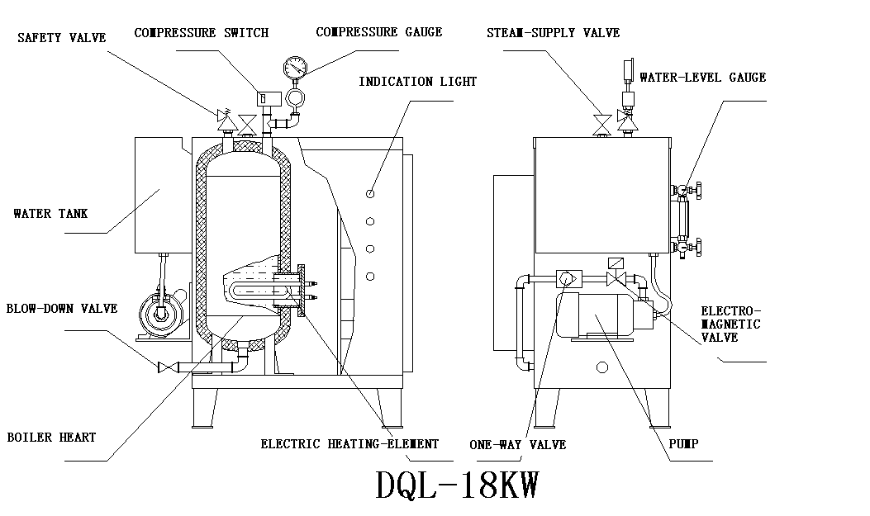
DQL-18/36 KW
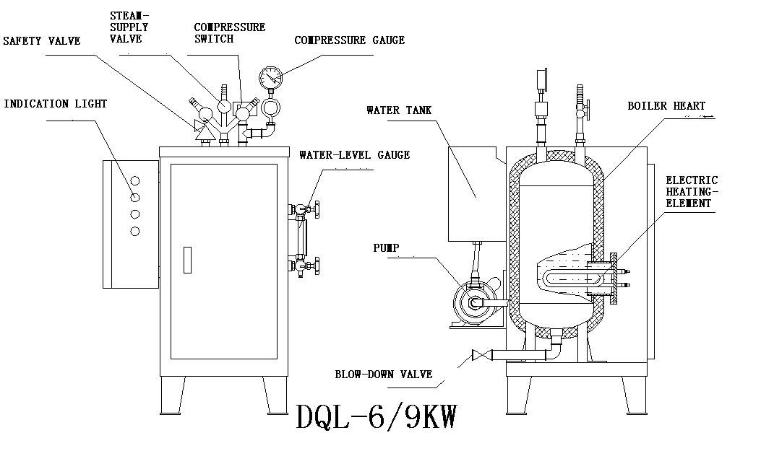

V、Installation
- The boiler must be grounded in the flat and solid foundation, keep horizontal.
- DQL-6 can be connected by 220V/1-phase or 380v/3-phase electricity. DQL-9, DQL-18 and DQL-36 use 380V/3-phase electricity. Customers must select the correct electricity in accordance with different models, and the boiler must be connected by a ground wire.
- The ambient of the boiler shall have sufficient vacant space.
- Customers shall install the water-inlet pipe with the water tank, blow-down pipe with blow-down valve.

VI、Operation
- Procedure of starting:
(1). Connect the water tank with the water, the floating ball device of the water tank will automatic control the water level. Attention, during the operation, please don’t cut off the water supply.
(2). Close the dirty discharging valve of the boiler. When the water is full, connect the power and turn on the power switch. The boiler water inlet lamp will turn on (Green lamp). The pump begins to supply water. The water level in the tank will descend quickly. If the water level doesn’t descend, it means the pump doesn’t supply water. You shall check the motor to see if it is running reverse and you shall see if there is air in the pump. The water inlet lamp will turn off quickly, and the heating lamp will turn on (red lamp). The electric heating elements begin to heat, and you should close the steam supplying valve first. When the steam pressure in the boiler reaches to the rated working pressure, the heating lamp power off, and the heating elements stop heating. You can open the steam supplying valve to provide steam.
- Method of steam output
(1). Direct output. Connect the iron with the boiler through a hose and control the steam output by the steam supplying ball valve. Simultaneously when you open the steam valve, the steam pressure will go down quickly, it is a normal phenomenon. After a while, the steam pressure will go up. If the steam consumption of the iron exceeds the steam generated by the boiler, the steam pressure will decline.
- (2). Using a special connector to control the steam output of the electric steam iron.
- Procedure of stopping the boiler
(1). Switch off the power
(2). Open the steam valve of the iron and boiler to exhaust the steam
(3). When the pressure is less than 0.05Mpa, open the dirty discharging valve slowly to completely exhaust the water in the tank. Attention, when the machine is just stopped, don’t exhaust the hot water in the tank immediately. Please exhaust some of the hot water, then add some cold water to reduce the temperature of the tank to exclude the possibility of damage of heating tubes. Because shrinkage of the air in boiler heart possibly makes the single-way valve open, water will go into boiler heart. Please keep the blow-down valve open to prevent the water from flowing into boil heart.
4. Never operate the boiler when there is no water in the tank. Check the water level frequently. The pressure of the outer water source shall not be too high, otherwise it will cause the overflow of the water from the water tank.
5. Customers shall choose the suitable steam boiler in accordance with their actual steam consumption. Otherwise, it may cause the wastage by using a big boiler while consuming little steam or providing deficient steam pressure by using a small boiler.
6. We suggest you that you had better use softened water or distilled water, or equip with a water softer in the inlet of the water tank to prolong the using life of the boiler.

VII、Maintenance
- If the machine being stopped for over 10 hours, you shall completely exhaust the water remained in water tank by opening the dirty discharging valve. But when the pressure in the boiler is too high, please don’t open the dirty discharging valve to avoid any danger.
- Please exhaust water from tank if keeping machine stop for long time.
3. After being operated for three months, the heating element, water level detection rods and the scale in the bottom of the boiler must be cleaned to guarantee the normal operation of the boiler. If there is much scale in the water level detection rods, you can use an abrasive cloth to remove the scale. Because the length of the three water detection rods is different, during the dismantling, pay attention to the wires connection. If the wires were connected wrongly, it will cause fault.
4. Clean the sieve mesh of the water inlet tube periodically.
VIII、Fault diagnosis

Phenomenon of fault | Possible reason(s) | Remedy
When starting the machine, the power lamp is not on and the boiler doesn’t work | - The outer power hasn’t been connected.  - The wire connecting the plug is loose or the plug can’t function properly.  - Fuse burn out | Check the outer power.  Make sure that the plug or wire is good.  Chang the fuse.
When starting the machine, the water adding lamp is on, but the pump doesn’t work | - Bad contact of pump wire.  - The pump malfunctions  - Alternating current contactor (JZ1) malfunctions | - Check the wire of the pump  - Repair the pump  - Check the alternating current contactor (JZ1)
When starting the machine, the water adding lamp is not on and the pump doesn’t work | - Bad contact of level controlling panel  - The water level detection rod is short circuit. | - Check the level controlling panel or the wire of level controlling panel  - Check the insulator and wire of the water level detection rod.
After starting the machine, the pump is continuously working, it can’t be shifted to heating status | - The level controlling panel malfunctions  - Alternating current contactor doesn’t work  - Pressure relay malfunctions | - Check the wire of the level detection rod and clean the rod.  - Change the level controlling panel.  - Check the pressure controller.  - Discharge the air in the pump and re-start the machine
After being heated, the pressure gauge shows no pressure | - Open the steam output valve and if there is steam being discharged out, it indicates that the pressure gauge is damaged or the pipe of the pressure gauge has been blocked  - Open the steam output valve and if there is no steam being discharged out, and if the heating lamp is not on, | Check the pipe-line or change pressure gauge, check water level controlling panel, heating tubes, pressure controller and alternating current contactor (JZ).
Steam pressure can’t reach to the rated pressure. | The precision of the pressure controller declines or the setting of pressure is incorrect | Change the pressure controller  Regulate the pressure
Steam pressure exceeds the rated pressure. | Pressure controller malfunctions or the setting of pressure is incorrect | Change the pressure controller  Regulate the pressure
The pipe-line leaks steam | The connections of the pipe-line have not been tightly connected, or there are cracks in the pipe-line connectors | Tightly connect the pipe-line or change the connectors.
The pump has abnormal noise | - The paddle of the pump has been damaged  - The bearings of the motor of the pump have been worn-out or damaged | Dismantle the pump and check
There is steam leaking out when the generator rises the pressure. | There is dirty in the non-return valve or the non-return valve malfunctions. | Exhaust the steam, and  turn on the power switch to supply the water, clean the sundries in the valve. If this can’t have any effect, the one-way valve and seal ring shall be changed.

PACKING LIST
Item No. | Name of commodity | Quantity
1 | DQL series electric steam boiler | 1 No.
2 | Operation manual | 1 piece
3 | Certificate of quality | 1 piece
4
5

SPARE PARTS LIST

Item No. | Name of commodities | Quantity
 | DZS-0.008-0.4 | 1
Inspector: Packer: Packing date:
CERTIFICATE OF QUALITY
质 量 证 明

Model No. DZS-0.008-0.4

产品型号._____________

Name

产品名称.___________

Serial No.

产品序号._________________

This machine has been successfully inspected and is allowed to sell
该产品已检验合格并准予出售

Inspector: Dean: Principal:

检验员:__________质检科负责人:______________厂长: __________

Date: Year Month Day

检验日期: 年 月 日

